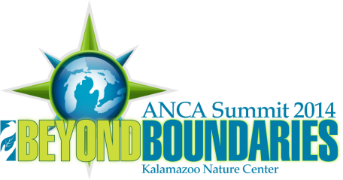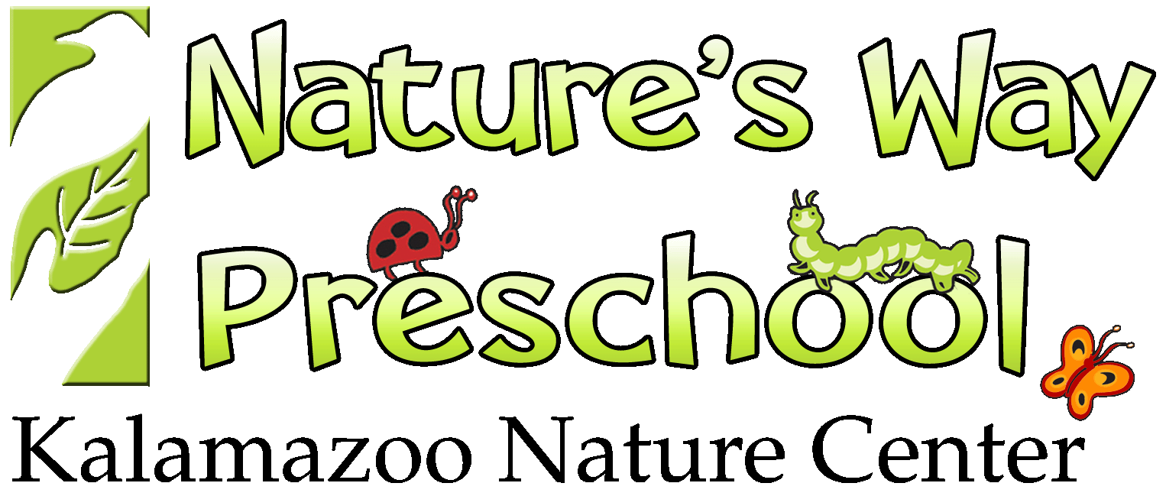Nature-based Preschool Conference
August 20-23, 2014
Kalamazoo Nature Center

Call for Presentations

Concurrent sessions will be held on Thursday, August 21 at the Nature’s Way Preschool Building. These will be traditional sessions – one hour presentations by 1 or 2 presenters (i.e., classroom management, family involvement, natural history).

Facilitated sessions will be held on Friday, August 22 at the Kalamazoo Nature Center. These are approximately one hour sessions where a presenter provides a 10-15 minute overview of a topic and then facilitates a group discussion (i.e., effective group hikes, activity ideas for a seasonal topic such as insects).

Name: Title:

Organization:

Mailing address:

City: State: Zip:

Phone: Email:

Co-presenter name: Title:

Organization:
*Please note all communication will be sent to the primary presenter listed.

Presentation Title:

Please select your session type: Concurrent Session (Thurs) Facilitated Session (Fri)

A/V needs: LCD projector and screen Overhead projector and screen Flip chart

Session description (50 words or less):

Other needs/requests:

Call for presentations must by received by May 9, 2014. Due to space and time limitations, proposal submission does not guarantee acceptance. Acceptance notifications will be provided by May 23.

Questions and submissions should be sent to Patti Bailie pattibailie@mac.com.

